CURRICULUM VITAE ET STUDIORUM 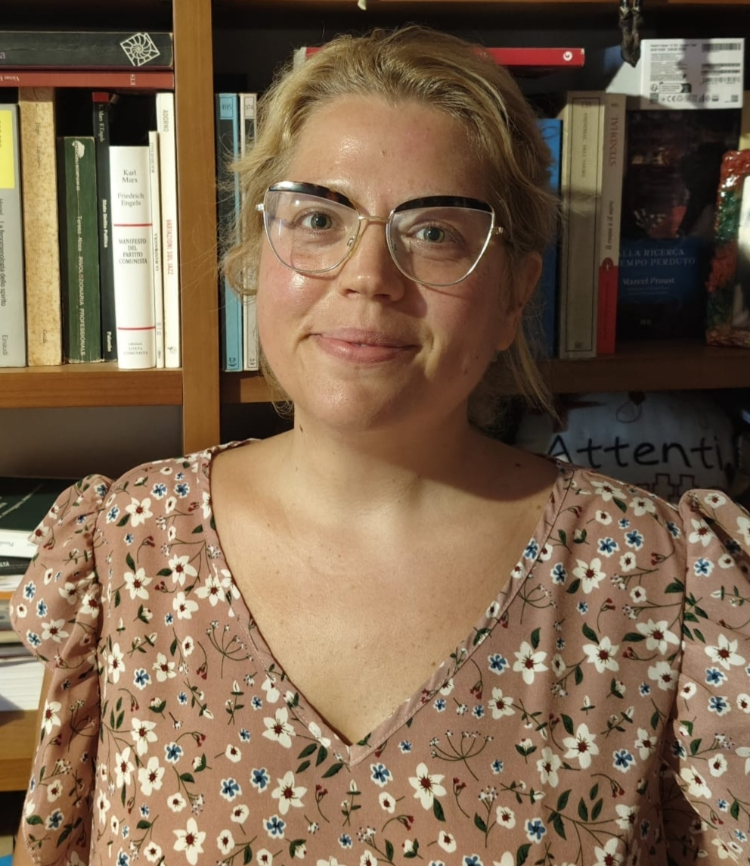
Letizia Cipriani

Letizia Cipriani has a heterogeneous research background, having served four years as a Research Fellow at the Department of Letters and Philosophy at the University of Florence (UNIFI). She is currently pursuing her PhD at the Niccolò Cusano University of Rome, where she also serves as an adjunct professor for Applied Neuroethics. Letizia is a co-founder of the start-up and spin-off, Aeffective, where she is co-responsible for research and development. Aeffective specializes in sentiment analysis and emotion recognition software. Her theoretical interests focus primarily on the category of "Time," with particular attention to the temporal processes of vital experience and phenomena in general, drawing on the philosophical insights of H. Bergson and B. Spinoza. On the application level, she deals with the relationship between qualitative experience and linguistic expression, focusing on ontology and its modeling. Letizia has published academic articles and has participated in several international conferences. Her current research project is centered on pain, highlighting her profile that integrates both pure theory and practical application.
EDUCATION AND TRAINING

- 2011 - 2013 Master Degree in Philosophical Sciences
University of Florence
Dissertation topic: “The bergsonian paradigm. For a time biology.”
Mentor: Professor Roberta Lanfredini
Mark: 110 cum Laude

- 2008 - 2011 Bachelor’s Degree in Philosophy
University of Florence
Dissertation topic: “Dretske’s naturalism and the issue of intention”
Mentor: Professor Paolo Parrini
Mark: 106/110

- 2003 - 2008 High school Diploma
ITC “F. Severi” – S. Giovanni Valdarno (AR)
Mark: 93/100

ACADEMIC ACTIVITIES

- Research activity

Adjunct Professor of Applied Neuroethics. Applied Philosophical Sciences (LM-78) (UNICUSANO, ROMA, 2025)

PhD in Well-being, Emerging Systems, and Bio-Psycho-Social Complexity of Niccolò Cusano University, Rome (2024-2026) Pain and Language: An Ontological, Phenomenological, and Hermeneutic Investigation of Suffering Experiences.

Research grant at University of Florence, DILEF (2022-2024) "An integrated approach to pain. Philosophical perspectives and ontological modeling"

Research grant at University of Florence, DILEF (2020-2022) "The phenomenological structure of irony: definitions and strategies of linguistic identification"

Since August 2019: co-responsible for research and development for the start-up-spin off Aeffective S.r.l. I deal with the application of philosophy to the analysis of natural language, with particular attention to the phenomenon of irony and emotions. Aeffective has a joint laboratory with the Qua-Onto-Tech research unit Q-Lab.

Since 2016 research Unit Collaborator for Qualitative Ontology and Technology (Qua-Onto-Tech) DILEF UNIFI

- Partaking in conferences

“Ontology of pain and the affordance of pain” talk at conference day “Pain and its expression: multidisciplinary perspectives” DILEF, University of Florence, Italy (01/15/2025)

“Translating Temporality: Revealing the Creative Power of the Sign in Bergson's Philosophy”, talk at PAMLA 120th ANNUAL CONFERENCE, Palm Spring, California, USA (11/7/24)

“A new ontology for understanding linguistic expression of pain. An interdisciplinary phenomenological, ontological, and technological perspective” talk at international conference ‘Negative Affectivity and Practical Possibilities’, University of Graz, Graz, Austria (10/17/24)
"Pain and intensity", Philosophy of Medicine: contemporary debates and new interdisciplinary perspectives. XXV WORLD CONGRESS OF PHILOSOPHY, ROME (8/5/24)

"Mens idea corporis: Spinoza and third way", talk at the International Conference: "Challenging concepts"organized by the University of Padua (2/21/24)

"On duration and memory in practices. Bergson and Heidegger.", talk at PAMLA 120th ANNUAL CONFERENCE, Portland, Oregon, USA (10/26/23)

“What if the Virtual was Practical?” talk at the International Conference: Interlacing Concepts and Practices organized by the University of Padua (9/6/23)

“Because ‘a thousand photographs of Paris are not Paris’”, talk at the seminar ‘Intelligence. Perspectives in theoretical philosophy.’ organized by the University of Florence (5/5/22)

“Strong Feelings Need Time. How Emotional Intensity is Shaped by Temporal Consciousness”, talk at The 7th EPSSE annual international
conference, University of Graz , with Doc. Ariele Niccoli. (6/11/2021)

“Emotional intensity and intuition.” talk at the seminar ‘Intuition. Open questions.’ organized by the University of Florence, research group QUA-ONTO-TECH, with Doc. Ariele Niccoli. (04/20/21)
“Intensity of qualitative states”, conference Five Emotions. Philosophycal arguments –University of Florence (10/05/2018)

“Intensity as qualitative progress." talk at workshop organized by the University of Florence research group QUA-ONTO-TECH (20/01/2017)

“Duration of qualia” talk at workshop organized by the University of Florence research group QUA-ONTO-TECH (15/07/2016)

- Publications

Manuscript in the making: “Sub specie durationis”, essay on Bergsonian philosophy, ETS
PISA, ‘Filosofie dell’esercizio’, expected delivery in 2025.

Cipriani L., (2025) Metaphorical Language of Pain: A Phenomenological and Embodied Perspective, Azimuth. Philosophical Coordinates in Modern and Contemporary Age Issue (1/2025). Accepted for publication.

Cipriani et al., (2025)., Ontological Modelling of Pain Experience, Global Philosophy, Springer. Accepted for publication.

Cipriani L, Lanfredini R. (2025) Temporal Traces of Experience: The Ontology of Orma. A Phenomenological Approach to Experiential Traces in Natural Language and Pain Narratives. Giornale di Filosofia, Vol 8, No 2. Accepted for publication.

Cipriani, L. (2024). Inverted Time: Unraveling Bergson’s Philosophy of Language and Certainty. Rivista Italiana di Filosofia del Linguaggio, 18(2).

De Marco, M., Cipriani, L., Baccini, M., Cherubini, G., Piazzini, M., Relli, G., ... & Cecchi, F. (2024, June). Development and Validation of a New Qualitative Pain Assessment Model: Preliminary Results of the WORDSforPAIN Project. In Italian Forum of Ambient Assisted Living (pp. 189-205). Cham: Springer Nature Switzerland.

Lanfredini, R., & Cipriani, L. (2023). The experience of pain and its ontological modelling from a philosophical point of view. Phenomenological description and ontological revision of the MPQ Questionnaire. Journal of Evaluation in Clinical Practice.

Lanfredini, R., & Cipriani, L. (2022). Esperienza ed espressione del dolore Un’indagine preliminare tra fenomenologia ed ermeneutica. The Experience of Pain. Epistemological, Hermeneutical and Ontological Aspects ed. by Luca Vanzago, 32(1), 47.
Book published in February 2020 published by Mimesis Edizioni “The vital rhythm” – Biography of Henri Bergson

- Editorial Work

Curated and managed the content for the special issue focused on CfP 1/2025: Multifaceted Embodiment. A (Meta-)Philosophical Assessment for Azimuth. Philosophical Coordinates in Modern and Contemporary Age.

Since 2018, member of the editorial board and head of communications for the book series Vite riflesse, published by Mimesis Edizioni.

- Conference Coordination and Organization

Conference day “Pain and its expression: multidisciplinary perspectives” organized by Roberta Lanfredini, Letizia Cipriani, Silvano Zipoli Caiani, DILEF, University of Florence, Italy (01.15.2025)

Co-coordinator of the seminar on Henri Bergson's Matière et Mémoire, organized by the Department of Letters and Philosophy (DILEF), University of Florence. (01/10/25-06/13/25)

- Teaching activities

Adjunct Professor of Applied Neuroethics. Applied Philosophical Sciences (LM-78) (2025)

Lecturer in Theoretical Philosophy DILEF, University of Florence (2025)

Lecturer in Theoretical Philosophy, University of the study of Niccolò Cusano, Roma (2025)

Since 2022, collaborator of the advanced course Filosofia in pratica, Department of Letters and Philosophy, University of Florence.

Class held in by the title “Emotion and language”, in the “Master in institutional advertising, multimedia communication and event creation” organized by DILEF, University of Florence (6/21/2024).
Four-classes cycle, “Mediality and models of the messenger: angel, virus and translation.” University of Florence, course of 'Critical thinking and argumentative strategies' in Humanistic Sciences for Communication (April-May 2024)
Class held in by the title “Pain and its linguistic expression”, in the ‘Chronicity and Lenitherapy: the end of care towards the end of life’ organized by Department of Experimental and Clinical Medicine, University of Florence, FILE (Italian Foundation of Leniterapia) and Fondazione CR Firenze (1/27/2024).
Class Held in by the title "The linguistic expression of pain and the problem of intensity", in Theoretical Reference Models in Rehabilitation 2023/2024, Master's Degree in Rehabilitation Sciences of the Health Professions, Department of Experimental and Clinical Medicine, UNIFI (12/21/23)
Class held in by the title "Time" in the Master Philosophy into practice, University of Florence (04/28/2023)

Class held in by the title "Irony and cancel culture." in the course of Critical thinking and argumentative strategies, University of Florence (20/04/2023)

Class held in by the title "Spinoza's emendation of the intellect" in the 'Master Yoga studies' organized by Ca' Foscari Challenge School, Università Ca’ Foscari Venezia (21/1/2023)

Class held in by the title “Experience and expression of pain: preliminary investigation”, in the ‘Chronicity and Lenitherapy: the end of care towards the end of life’ organized by Department of Experimental and Clinical Medicine, University of Florence, together with File (Italian Foundation of Leniterapia) and Fondazione CR Firenze (10/29/2022)

Class held in by the title “The problem of irony: strategies of individuation and cases studies”, in the ‘Master in institutional advertising, multimedia communication and event creation’ organized by DILEF, University of Florence (06/10/22)
Class held in by the title “The problem of irony: open questions and strategies of individuation”, in the ‘Master in institutional advertising, multimedia communication and event creation’ organized by DILEF, University of Florence (06/17/21)
Class held in Laboratory of Theoretical Philosophy by the title “Become. Variations on the theme.” University of Florence, course of Master Degree in Philosophical Sciences. (05/29/2019)

Class held in Laboratory of Theoretical Philosophy by the title “The issue of identification. Empathy.” University of Florence, course of Master Degree in Philosophical Sciences. (05/09/2018)

Three-classes Cycle, “Introduction to Matter and Memory. The vital turn of Henri Bergson: for a pure time biology.” University of Florence, course of Master Degree in Philosophical Sciences (04/03-04-11/2018).

- Partaking in cycles of philosophical conferences

International conference: What is time? Einstein-Bergson 100 years later,
held in the University of Aquila and Gran Sasso Science Institute (April 4-6 2019)

Permanent seminary of Aesthetics, organized by Professor Gianluca Garelli and held in the Department of Philosophy of Florence (2012-2013)

Laboratory of Theoretical Philosophy organized by Professor Roberta Lanfredini and held in Department of Philosophy of Florence (2012)

FURTHER EXPERTISES

- Language proficiencies

Italian: Mother-tongue
English: decent written and oral comprehension, decent written and oral production.
French: fluent written and oral comprehension, decent written and oral production.

FURTHER EMPLOYMENTS

Since August 2019: responsible for research and development for the start up-spin off Aeffective S.r.l. I deal about application of philosophy to the analysis of natural language, with particular attention to the phenomenon of irony and emotions.

2019-2020: Passionate teacher in artistic high school “Benedetto Varchi”, in Montevarchi (Arezzo, Italy): help-provider for young students with learning and mental disabilities.

Since October 2015: Operator at the Intercommunal Dog Shelter ENPA Valdarno in Cavriglia (Arezzo).

Since 2012: Animal therapy: ENPA volunteer and manager.

Since 2016: Protection of migrants: Baobab experience volunteer.

Semi-professional soul-blues and jazz singer with experiences in California, USA.

